Free Response Question Practice
- Assume Smithland is in short-run equilibrium at a level of output that exceeds the full-employment level of output.
(a) Draw a correctly labeled graph of the aggregate demand, short-run aggregate supply, and long-run aggregate supply curves, and show each of the following.
(i) The current equilibrium real output and price level, labeled Y₁ and PL₁, respectively (ii) The full-employment output, labeled Y_F
(b) Assume there is an increase in the price of oil. What is the effect on equilibrium real output, labeling the new short-run equilibrium real output Y₂.
(c) Based solely on the change in real output on your graph in part (b), what will happen to each of the following in the short run?
(i) The natural rate of unemployment
(ii) Nominal interest rates. Explain.
(d) Assume instead the central bank intervenes to bring the economy closer to Yf. What policy should the central bank take in an ample reserves economy?
e) Assume that the government takes no action. What would occur in the long run to return the economy back to a long run equilibrium?

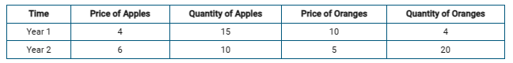
- The table above shows data for the economy of Fruitland, which produces two goods, apples and oranges.
(a) Calculate the nominal gross domestic product (GDP) for year 2. Show your work.
(b) Using year 1 as the base year, calculate real GDP for year 2. Show your work.
(c) Calculate the GDP deflator for year 2. Show your work.
(d) Assuming the market basket is composed of the quantities in year 1, calculate the consumer price index (CPI) for year 2. Show your work.
(e) Suppose apple and orange pickers received a 2 percent increase in their wages. Based on your answer to part (d), would real wages of apple and orange pickers increase, decrease, or stay the same from year 1 to year 2 ? Explain.

